PostgreSQL Database Maintenance And Performance Analysis

Brief summary
This document contains an end-to-end PostgreSQL maintenance and performance exercise in the isolated vacuum_practice database. The sequence creates and populates public.vacuum_demo with 10,000 rows, changes and deletes rows to create dead-tuple activity, compares statistics before and after manual VACUUM/ANALYZE, and evaluates sequential scans, bitmap scans, and index scans. It then reviews index-use counters and global autovacuum settings, temporarily lowers the table-specific vacuum threshold, checks active transactions and transaction-ID freeze age, restores the global defaults, and runs a controlled update sequence to observe autovacuum and autoanalyze.

Overall results at a glance
- The practice table began with 10,000 rows; after the intentional deletion of IDs 3001–5000, 8,000 visible rows remained.
- Manual VACUUM (ANALYZE, VERBOSE) completed, and the subsequent statistics showed 8,000 live rows and zero estimated dead tuples.
- The status and composite indexes changed the chosen plans, but index use did not always reduce the single-run elapsed time. The planner estimated 375 rows for a query that returned 1,001, illustrating the value of comparing estimates with actual rows.
- The global vacuum settings observed were threshold 50 and scale factor 0.2. The temporary per-table scale factor of 0.05 implied an approximate threshold of 450; those overrides were subsequently reset.
- In the final controlled update exercise, PostgreSQL recorded an additional autovacuum run and autoanalyze. The final captured stats showed 8,000 live tuples, zero estimated dead tuples, manual vacuum count 1, and autovacuum count 5.

How to read this review
Each numbered section maps to one screenshot in the same order as the uploaded document. “Implementation” explains the commands or checks shown. “What to look for” highlights the output that supports the interpretation. Tuple counts and execution times are snapshots from the screenshots—not guaranteed current values or a benchmark. The screenshots include read-only monitoring of database names such as lyris_prod, but the maintenance changes shown target vacuum_practice.public.vacuum_demo.
Important interpretation note: PostgreSQL statistics such as n_live_tup, n_dead_tup, and n_mod_since_analyze are estimates/counters that may change as autovacuum or autoanalyze runs. An empty pg_stat_progress_vacuum result means no matching vacuum was active at the exact time of that query; it does not mean a vacuum never ran.

Screenshot 01 — Database, table, and initial workload
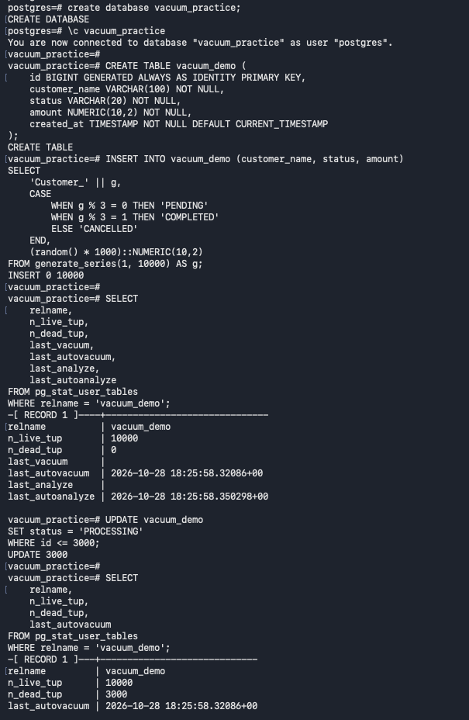
Implementation: Creates the dedicated vacuum_practice database, connects to it, creates public.vacuum_demo, inserts 10,000 generated rows, checks the initial table statistics, then updates IDs 1–3000 to status PROCESSING.
What to look for in the output: Look for CREATE DATABASE, CREATE TABLE, INSERT 0 10000, and UPDATE 3000. The first statistics show about 10,000 live rows. After the status update, n_dead_tup is estimated at 3,000 before later maintenance. Statistics are estimates and may change after autovacuum runs.

Screenshot 02 — Autovacuum enabled and table options
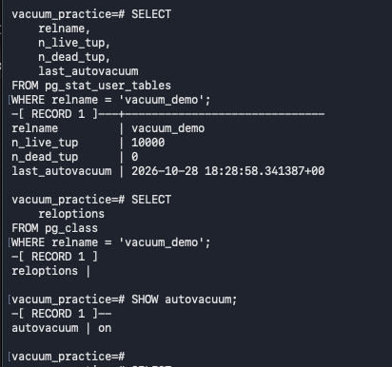
Implementation: Rechecks vacuum_demo statistics, inspects pg_class.reloptions, and runs SHOW autovacuum to confirm automatic maintenance is enabled.
What to look for in the output: autovacuum = on confirms the feature is enabled. Empty reloptions means no table-specific storage/autovacuum options are set at that moment, so the table inherits applicable defaults. n_dead_tup = 0 in this later check shows cleanup had occurred by the time statistics were read.

Screenshot 03 — Tuple activity and deletion of 2,000 rows
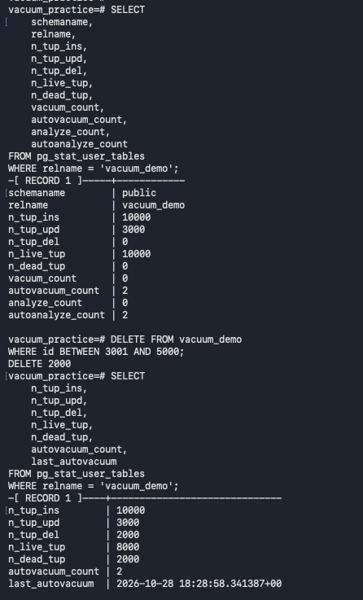
Implementation: Queries pg_stat_user_tables counters, deletes IDs 3001–5000, and queries the counters again.
What to look for in the output: Before deletion, n_tup_ins is 10,000 and n_tup_upd is 3,000. The DELETE reports 2,000 rows; afterward n_tup_del is 2,000, estimated live rows are 8,000, and n_dead_tup is estimated at 2,000. Deleted row versions can remain until eligible for vacuum cleanup.

Screenshot 04 — Manual VACUUM (ANALYZE, VERBOSE)
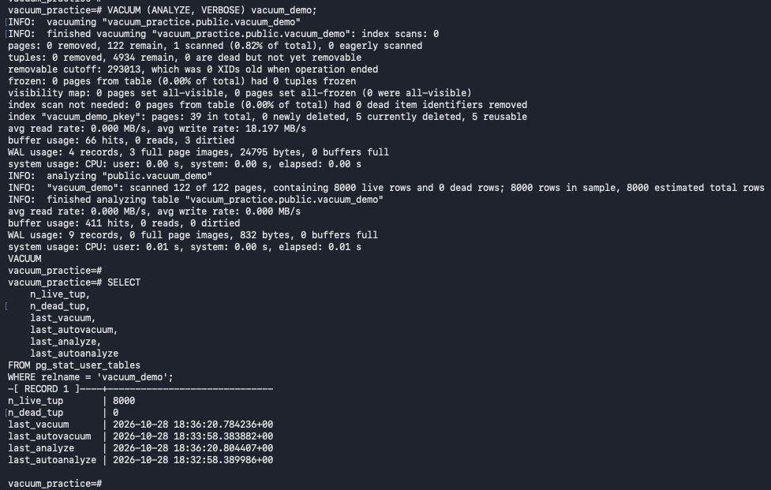
Implementation: Runs VACUUM (ANALYZE, VERBOSE) on vacuum_demo and checks pg_stat_user_tables afterward.
What to look for in the output: The command completes successfully. The verbose output reports the heap/index work and then ANALYZE scans 122 pages, finding 8,000 live rows and 0 dead rows in its sample. Later statistics show n_live_tup = 8,000, n_dead_tup = 0, plus updated manual-vacuum/analyze timestamps. VACUUM output details and tuple counts can differ from the statistics estimates.

Screenshot 05 — Baseline plan for status = COMPLETED
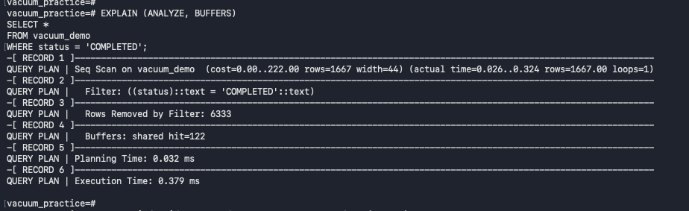
Implementation: Runs EXPLAIN (ANALYZE, BUFFERS) for SELECT * FROM vacuum_demo WHERE status = 'COMPLETED' before adding the status index.
What to look for in the output: The plan uses Seq Scan, returns about 1,667 rows, and reports 6,333 rows removed by the filter. Execution Time is about 0.379 ms in this run. This is the baseline for comparison; timings are affected by cache and environment and are not a repeatable benchmark.

Screenshot 06 — Create status index and compare plans
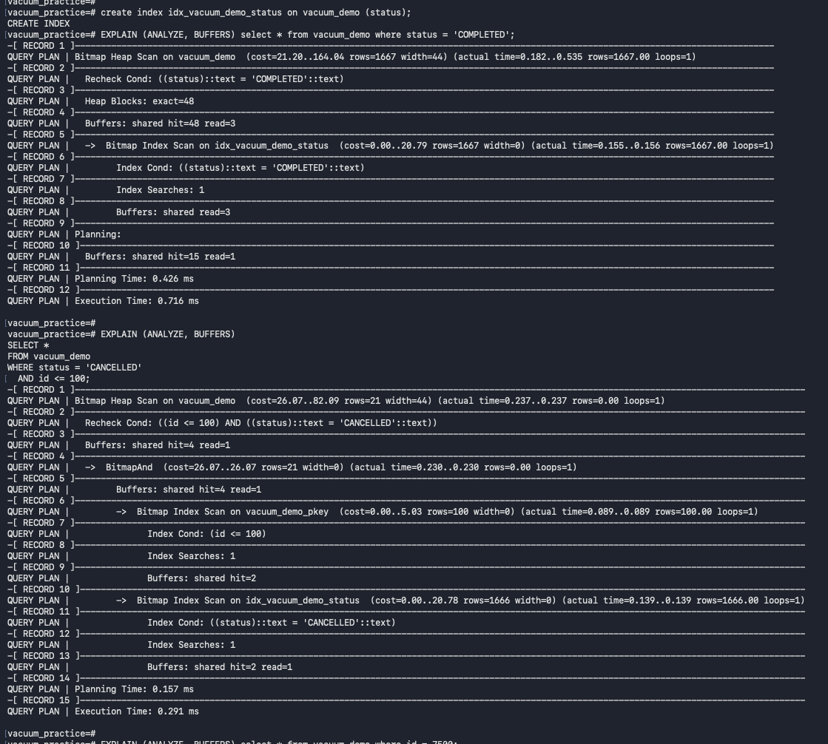
Implementation: Creates idx_vacuum_demo_status on status, reruns the COMPLETED query, then tests a CANCELLED query constrained to id <= 100.
What to look for in the output: The COMPLETED query uses Bitmap Index Scan plus Bitmap Heap Scan and takes about 0.716 ms in this observation—slower than the earlier single sequential-scan measurement despite using the index. The CANCELLED/id query returns zero rows because IDs 1–3000 had been changed to PROCESSING; its plan combines index conditions. An index is not automatically faster for every query.

Screenshot 07 — Primary-key lookup and status-plus-range query
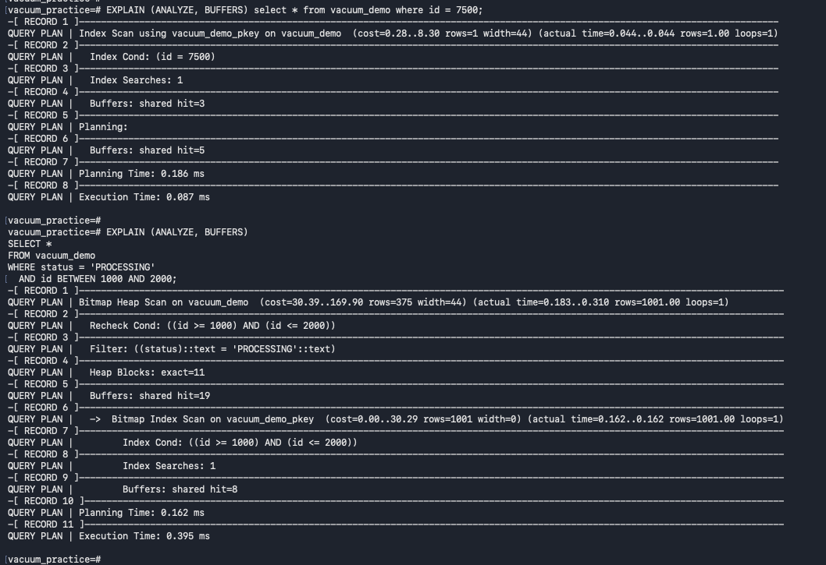
Implementation: Explains a lookup for id = 7500, then queries PROCESSING rows with IDs 1000–2000 before a composite index is created.
What to look for in the output: The single-ID query uses the primary-key index and returns one row. The status-plus-range query uses a bitmap scan from the primary-key index and then filters on status; it returns 1,001 rows although the planner estimates 375. That estimate/actual gap is evidence to monitor, especially if it materially affects plan choices.

Screenshot 08 — Create composite index on (status, id)
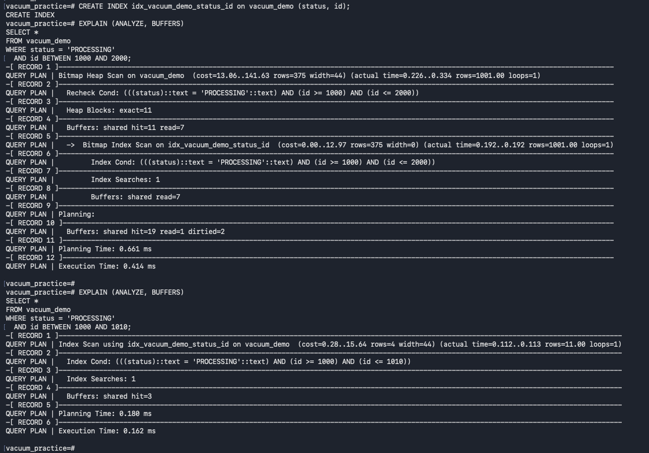
Implementation: Creates idx_vacuum_demo_status_id and tests both a wider ID range (1000–2000) and a narrow range (1000–1010) for PROCESSING rows.
What to look for in the output: For the wider range PostgreSQL uses the composite index with a Bitmap Heap Scan and returns 1,001 rows; the observed execution time is about 0.414 ms. For the narrow range it uses an Index Scan and returns 11 rows, at about 0.162 ms. Index strategy changes with selectivity and returned-row volume.

Screenshot 09 — Query filtering only PROCESSING status
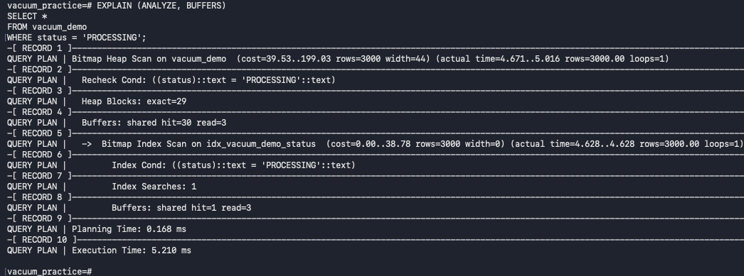
Implementation: Runs EXPLAIN (ANALYZE, BUFFERS) for all rows where status = 'PROCESSING'.
What to look for in the output: The status index is used through a Bitmap Index Scan and Bitmap Heap Scan, returning 3,000 rows with an observed execution time around 5.210 ms. Since this query returns a substantial fraction of the table, using an index does not guarantee the best elapsed time. Compare plans and workload conditions rather than assuming index use equals improvement.

Screenshot 10 — Index usage statistics and primary-key range
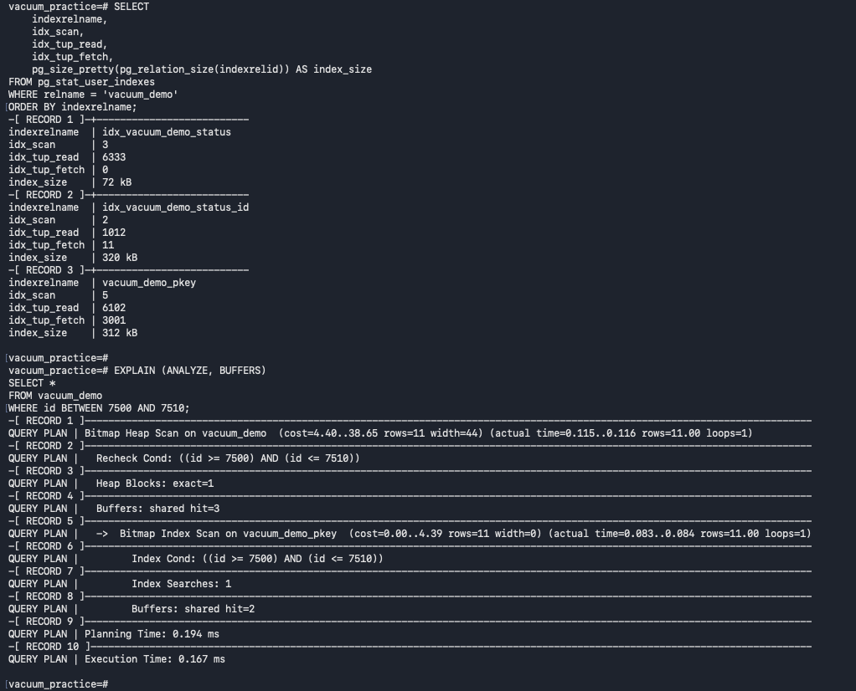
Implementation: Queries pg_stat_user_indexes for scans, tuple reads/fetches, and index sizes, then explains an ID range from 7500 through 7510.
What to look for in the output: The screenshot reports status index: 3 scans and 72 kB; composite index: 2 scans and 320 kB; primary-key index: 5 scans and 312 kB. The range query returns 11 rows using the primary-key index. Statistics are cumulative and can reset. idx_tup_fetch does not account for all bitmap-scan behavior, so zero there alone does not prove an index is unused.

Screenshot 11 — ANALYZE and repeat the composite-index query
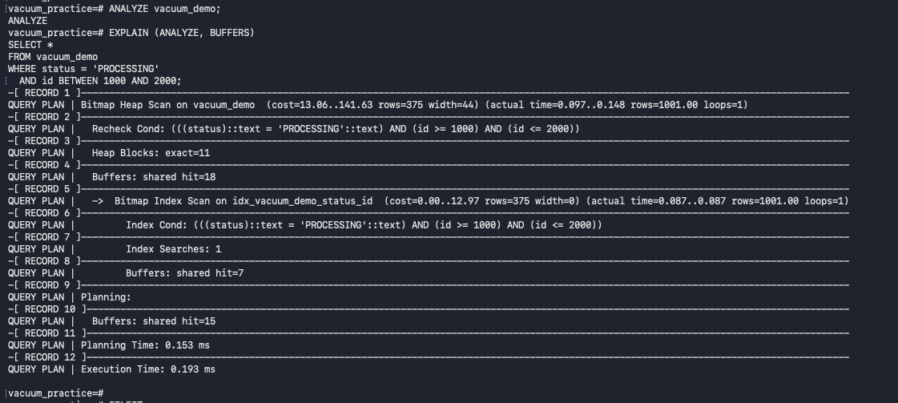
Implementation: Runs ANALYZE vacuum_demo and repeats the PROCESSING/ID 1000–2000 execution plan.
What to look for in the output: The composite index is used and 1,001 rows are returned, but the estimate remains 375. Execution time in this run is about 0.193 ms. ANALYZE refreshes planner statistics, but it may not eliminate estimation errors involving correlated columns; assess whether the difference affects plan quality.

Screenshot 12 — Inspect global autovacuum configuration
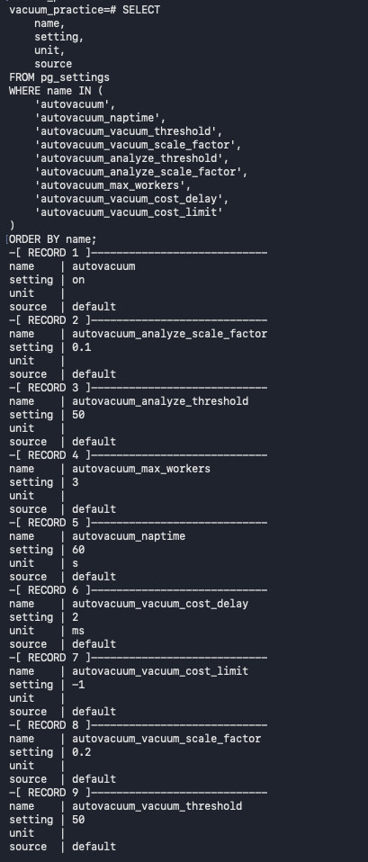
Implementation: Queries pg_settings for autovacuum enablement, thresholds, scale factors, worker limit, launcher nap time, and cost settings.
What to look for in the output: Observed defaults include autovacuum = on, vacuum threshold = 50, vacuum scale factor = 0.2, analyze threshold = 50, analyze scale factor = 0.1, max workers = 3, naptime = 60 seconds, and vacuum cost delay = 2 ms. source = default identifies the source of these values. These settings define eligibility and pacing, not a guaranteed start time.

Screenshot 13 — Record maintenance baseline and set table overrides
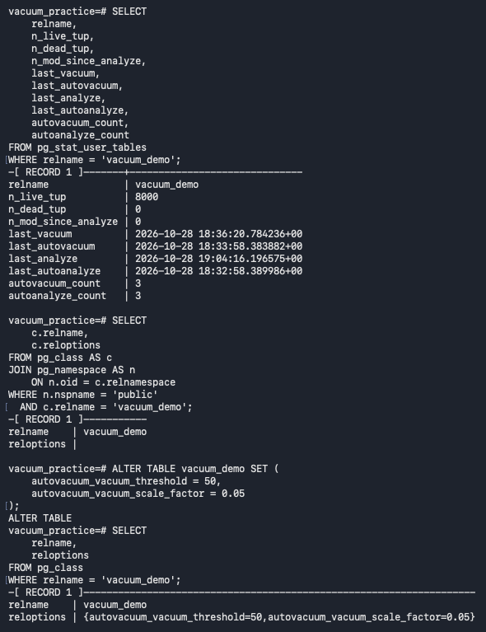
Implementation: Captures vacuum_demo's recent statistics, confirms reloptions are empty, sets autovacuum_vacuum_threshold = 50 and autovacuum_vacuum_scale_factor = 0.05, and verifies the options.
What to look for in the output: The final reloptions should show both table overrides. With about 8,000 estimated rows, this setting implies an approximate trigger of 50 + (8,000 × 0.05) = 450 estimated dead tuples. The baseline statistics show 8,000 live rows and no estimated dead tuples before the demonstration update.

Screenshot 14 — Update 500 rows and observe table-specific autovacuum
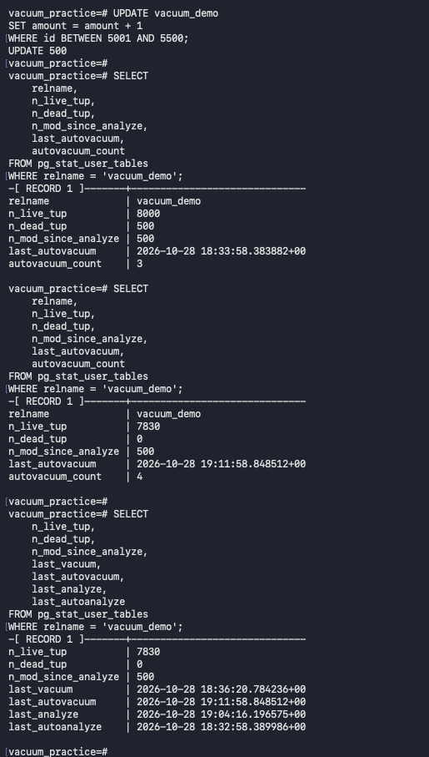
Implementation: Updates amount for IDs 5001–5500, then checks statistics more than once as automatic maintenance occurs.
What to look for in the output: The UPDATE reports 500. An initial sample shows n_dead_tup = 500 and n_mod_since_analyze = 500. A later sample shows n_dead_tup = 0, autovacuum_count incremented from 3 to 4, and last_autovacuum advanced to 19:11:58 UTC. n_live_tup changing to 7,830 is a statistics estimate; it does not mean exactly 170 rows were lost.

Screenshot 15 — Inspect active transactions and backend xmin
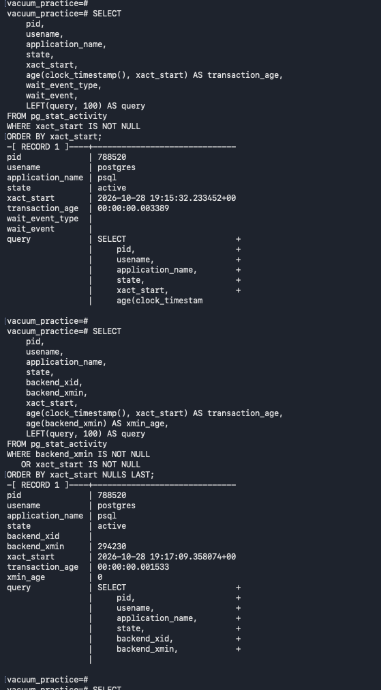
Implementation: Queries pg_stat_activity to review transaction ages, wait events, backend_xmin, and SQL text.
What to look for in the output: Only the current psql session is shown in the captured output. Its transaction age is very small and age(backend_xmin) is 0, so the screenshot does not show evidence of an old transaction or snapshot blocking cleanup at that moment. For an incident, review all relevant sessions and look for old xact_start values or idle-in-transaction sessions.

Screenshot 16 — Check database-wide transaction ID freeze age
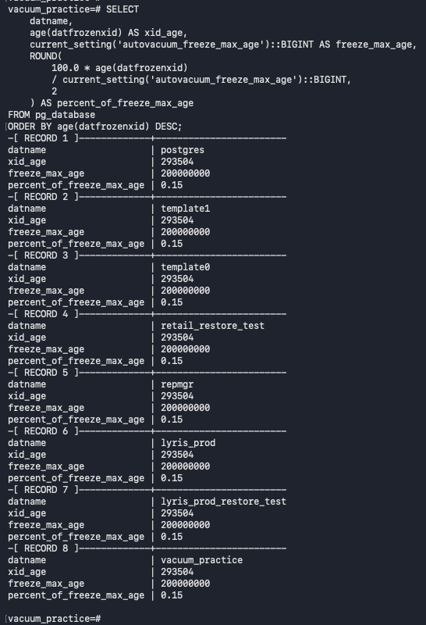
Implementation: Calculates age(datfrozenxid) for each database and compares it with autovacuum_freeze_max_age.
What to look for in the output: The captured databases show xid_age about 293,504 against a freeze maximum of 200,000,000—approximately 0.15%. This is low in the screenshot and does not indicate immediate freeze-age pressure. The query is read-only; its listing includes lyris_prod, but no production data or configuration is changed.

Screenshot 17 — Check table XID age and restore global defaults
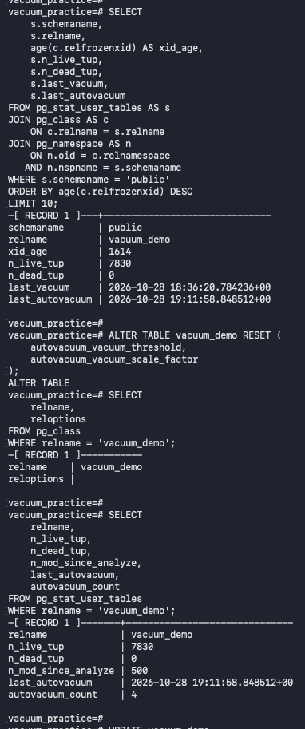
Implementation: Joins pg_stat_user_tables with pg_class to check vacuum_demo's relfrozenxid age, resets the table-level autovacuum overrides, and confirms reloptions is empty.
What to look for in the output: The table xid_age is about 1,614, with n_dead_tup = 0 in this sample. ALTER TABLE ... RESET removes the two overrides; an empty reloptions result confirms the table inherits global settings again. The later statistics shown still have the prior counts and timestamps from this phase of the exercise.

Screenshot 18 — Generate first 1,000-row update in incident exercise
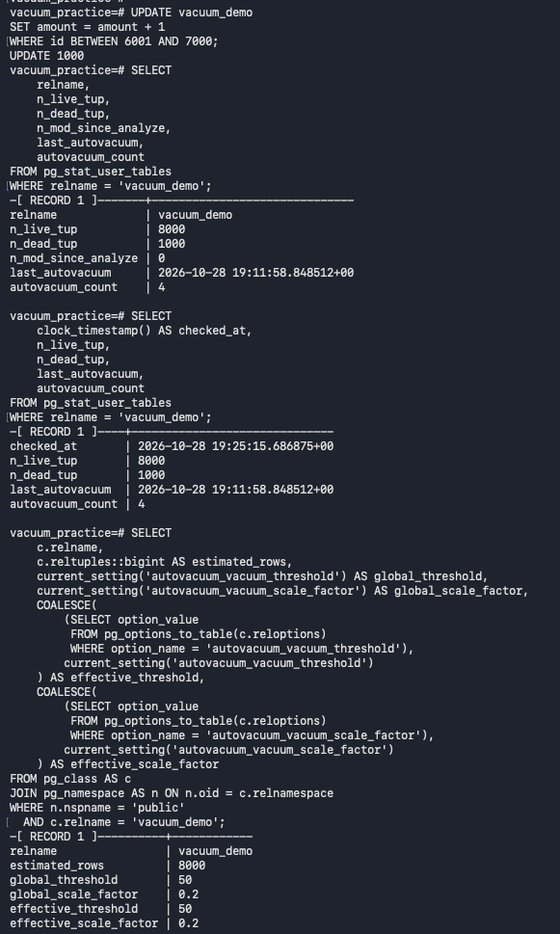
Implementation: Updates amount for IDs 6001–7000, checks tuple statistics, waits/checks again, and calculates the effective vacuum threshold from current table settings.
What to look for in the output: The update reports 1,000. At the 19:25:15 UTC check, n_dead_tup is 1,000 and autovacuum_count remains 4. The effective threshold is 50 plus 20% of about 8,000 rows = approximately 1,650. The 1,000 estimate is below that trigger, so another autovacuum run is not yet recorded. n_mod_since_analyze is a separate counter.

Screenshot 19 — Second 1,000-row update and final autovacuum result
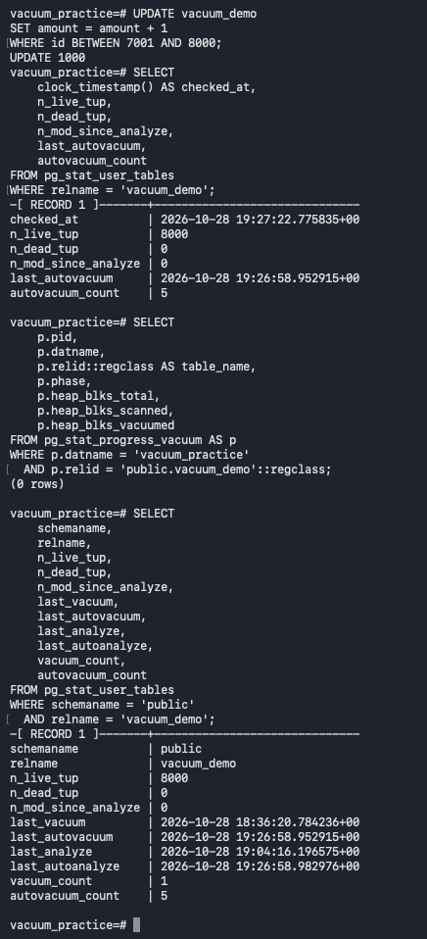
Implementation: Updates IDs 7001–8000, checks statistics, checks for an active vacuum operation, and takes a final snapshot.
What to look for in the output: At 19:27:22 UTC, n_live_tup is 8,000, n_dead_tup is 0, last_autovacuum is 19:26:58.952915 UTC, and autovacuum_count has increased to 5. last_autoanalyze is shortly afterward. pg_stat_progress_vacuum returns 0 rows because no matching vacuum is active at that instant; this is consistent with a completed run. The observations confirm an additional automatic vacuum, but do not prove the exact statement that triggered it.

